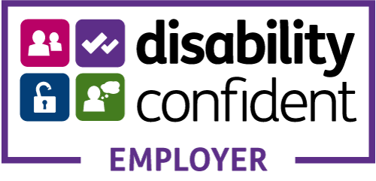

Job Description:
Title: Social Media & Communications Volunteer
Reports to: Chuckle Directors
Employment status: Volunteer role
Hours of work: 4 - 6 hours per week.
Pay: Unpaid role (but any pre-agreed reasonable expenses paid)
Base: Blend of remote working/ working at The Chuckle House, with regular meetings at the Chuckle House.
Job Purpose Summary: Chuckle is looking for a volunteer to help co-ordinate, design and create social media and online content about Chuckle to raise our profile, increase our reach & keep our audiences engaged.
Key Responsibilities:
- Generate content and visuals for use across various social media platforms.
- To explore and create a presence on new social media platforms.
- To report back on effectiveness of campaigns, analysing performance.
- Working with the fundraising department to run fundraising and awareness campaigns.
Skills Profile:
- Strong written and verbal communication style
- Good attention to detail, organised, works well to deadlines.
- Able to create exciting, fun content whilst adhering to the Chuckle Brand.
- Good understanding of how to blend different content across different social media platforms in order to achieve the correct communication.
- Ability to use online software such as Meta Business Suite to plan and deliver timely campaigns.
- Competent in content and photography and basic video editing.

Person Profile:

The ideal person for this role needs to understand and align with of Chuckles ethos of equality, diversity and inclusion in all that we do at Chuckle. The role requires a person who can juggle multiple campaigns, and work fast and efficiently to a deadline.

As an inclusive employer we welcome applications from all backgrounds, and as a disability confident employer we would love to hear from volunteers who are differently abled.
The post holder must sign up for a commitment to equal opportunities and to our safeguarding statement below.
Safeguarding and promoting the welfare of children.
At Chuckle Production we recognise our moral and statutory responsibility to safeguard and promote the welfare of children/young people and expect all staff and volunteers to share this commitment.
This means that we have a Safeguarding and Child Protection Policy and other procedures in place. Parents and carer’s are welcome to read the Policy on request, details are also on our website.
Sometimes we may need to share information and work in partnership with other agencies when there are concerns about a child’s welfare. We will ensure that our concerns about our children/young people are discussed with his/her parents/carers first unless we have reason to believe that such a move would be contrary to the child’s welfare. The post holder will need to be DBS checked and training will be given regarding the current regulatory requirements.

